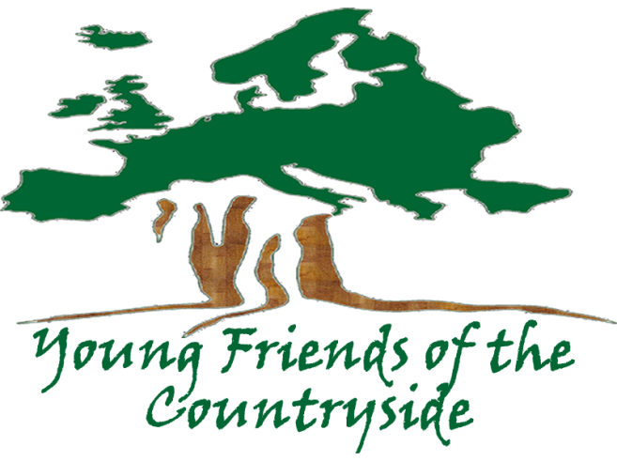
2019 FAMIGRO
Award for Entrepreneurship
- Application Form -

Name of the project

Date

Foreword
YFCS promotes the role of young people in preserving the future of Europe’s countryside and aims to provide them with the tools to do this in the best way possible.
In order to effectively encourage the future generation of landowners, YFCS has developed the the Young Entrepreneurs´ Award (since 2013 it has been named the “Famigro Award” for Entrepreneurship). This initiative was created by Karl Grottenfelt and so far has recognized and rewarded three successful entrepreneurs between the age of 18 and 35. Also thanks to the financial support given to them by the Young Entrepreneurs´ Award, they are still leading a successful business today.
Description of the Award
Subject:
The purpose of this award is to engage European young entrepreneurs to develop projects that address the immediate needs for developing a healthy and sustainable countryside while also serving to boost the livelihood of the rural community.
Eligibility criteria:
The applicant shall:
- Be a European citizen or permanent resident, or
- A group of Europeans represented by one person
- Between the age of 18 and 35
- Never have been awarded this prize
- Re apply if previously unsuccessful
The business should:
- Be a for-profit business
- Be registered and have its head office in the EU
The project:
- Is already being implemented or has a solid business plan for the near future
- Has a long-term scope and aims at future developments
- The business plan shows the development of one or more activities aiming at generating financial funds ensuring the continuity of the private enterprise
- Aims at developing innovative solutions for the creation and conservation of local economic development and fostering business opportunities
- Is an example of good practice to other (rural) communities and is scalable and adaptable to different rural contexts

Selection criteria:
- Best practices and replicability
- Long-term vision of the project
- Novel and innovative ideas
- Projects that are scalable
- Solutions that favour the development of rural economies and foster business opportunities
- Projects that contribute to improve the environment
Prize description:
- A EUR 5,000.00 prize and diploma of recognition
- Advertisement on the communication of the YECS, FCS and ELO Channels
- An article in the Countryside Magazine (more than 4,000 readers)
- The opportunity to present the project at the Forum for Countryside Entrepreneurship and at the FCS & YFCS General Assembly
Deadline:
The deadline for the 2019 award application is April 30. Applications must be sent to the following addresses:
Geoffroy De Canniere:
geoffroydecanniere@gmail.com
Alberto Hermosel:
alberto.hermosel@elo.org

SECTION A
Administrative Information

Applicant/Representative of the applicant
Short name

Legal Information on the Applicant
Legal Name |  | Legal Status
 |  | ☐Public
 |  | ☐Private
 |  | ☐Natural Person
Date of birth
Street Name and No. |  | P.O.Box
Post Code |  | Town/City
Country Code |  | Country Name
Position in the company

Legal Address of the Applicant
Street Name and No. |  |  | P.O. Box
Post Code |  | Town/City
Country Code |  | Country Name

Applicant Contact Person Information (only if different from above)
Title |  | Function
Surname |  | First Name
Street Name and No |  |  | P.O. Box
Post Code |  | Town/City
Country |  | Fax No
Telephone No |  | Website
E-mail
Position in the company

Location of the project area (only if different from above)
Name
Address
Town/City |  | Post Code
Country
Telephone No. |  | Fax No
E-mail |  | Website

Presentation of the team

Partner 1

Legal Information on the Applicant’s Partner (if any)
Legal Name |  | Legal Status
 |  | ☐Public
 |  | ☐Private
 |  | ☐Natural Person
Date of birth
Street Name and No. |  | P.O.Box
Post Code |  | Town/City
Country Code |  | Country Name
Position in the company

Contact Person Information (only if different from above)
Title |  | Function
Surname |  | First Name
Date of birth
Street Name and No |  |  | P.O. Box
Post Code |  | Town/City
Country
Telephone No |  | Fax No
E-mail |  | Website
Position in the company

Partner 2

Legal Information on the Applicant’s Partner (if any)
Legal Name |  | Legal Status
 |  | ☐Public
 |  | ☐Private
 |  | ☐Natural Person
Date of birth
Street Name and No. |  | P.O.Box
Post Code |  | Town/City
Country Code |  | Country Name
Position in the company

Contact Person Information (only if different from above)
Title |  | Function
Surname |  | First Name
Date of birth
Street Name and No |  |  | P.O. Box
Post Code |  | Town/City
Country
Telephone No |  | Fax No
E-mail |  | Website
Position in the company

SECTION B
Executive Summary of the Project
Project outlines
Project Timeframe

Project Area (including history, features in max. 500 characters)

Project vision, objectives, and goals
General vision of the project (max. 500 characters)

Main principles on which the project focuses (max. 500 characters)

Short-term objectives (max. 250 characters)

Long-term objectives (max. 250 characters)

Additional elements/targets (if any) (max. 250 characters)

Business Model
Business Model - including economic feasibility of the project on the long term. (max. 1800 characters)

General Description of the Project
Project Description (max. 1800 characters)

Letter of movitation
Letter of movitation - A letter addressed to the jury explaining why the project fits the aims of this award. (max. 2 pages)

SECTION C
Annexes

Key Figures of the Business Plan

Acknowledgement of Receipt

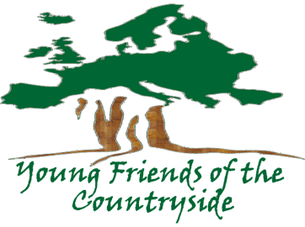 | Young Friends of the Countryside  Rue de Trèves, 67  B – 1040 Brussels

Name of Applicant*

Contact Person*

Fax*

Title of the Project*

*to be filled out by the applicant

Sir / Madam,

I acknowledge receipt of your proposal for which I thank you.
Your proposal will be examined by the members of the Jury, with respect to its eligibility. Those projects declared eligible will then undergo an evaluation procedure by the Jury.
I will let you know the final decision, as soon as it has been taken.

Yours faithfully,

Signature:

